Introduction

The 2021 Environmental Science Education: Hydrology and GIS Workshop at UCR will focus on educating credentialed high school and pre-service STEM teachers with the pedagogy and techniques to integrate scientific contents related to water resources and GIS in their classrooms.
The workshop, funded by the National Science Foundation and co-sponsored by the UCR CalTEACH- Science Mathematics Institute (SMI), is led by Professor Hoori Ajami with the aim of integrating knowledge from chemistry, physics, and mathematical sciences in problem solving and interpretation of issues in water resources. Participants who complete the workshop will be provided with teaching materials necessary for transferring their knowledge into their classrooms.
These resources cover important materials related to hydrologic cycle, groundwater recharge processes and water management.
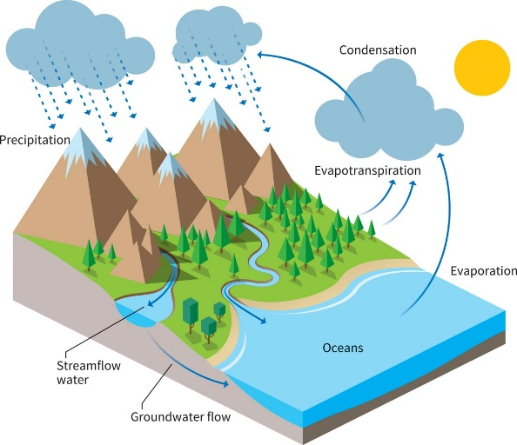

Anticipated Outcomes

Participants can expect to
- Learn about physical principles governing water balance;
- Learn on the use of GIS data and maps in teaching science;
- Gain skills in applying knowledge from physics and mathematics for problem solving in water resources.

Environmental Science Education:
HYDROLOGY and GIS Workshop

Dates:
July 29-30, 2021
Time:
10:00 am-4:00 pm (Instruction and
Group Work)

Location:
Online via Zoom

Eligible Applicants:
Credentialed High School Science Teachers

**Participation Stipend**
$500 upon completion

APPLICATION- Please answer the following questions to assist the selection process:
- Is your baccalaureate/post-baccalaureate degree in science, math, or engineering?
_____Yes _____No
Application Deadline:
June 15, 2021

To apply for this workshop, fill out and email the application form to Prof. Ajami (hooria@ucr.edu ) by June 15, 2021.

Questions: Contact Prof. Ajami
(hooria@ucr.edu)

Please indicate your subject area/ major _____________________________

- School site information:
School name ____________________________
School district ___________________________
- What courses do you currently teach? __________________________

- Indicate which type of teaching credential you hold:
_______Preliminary Teaching Credential

_______Professional Clear Teaching Credential

5.Briefly describe your primary motivation to participate in this workshop:

Contact Information:

Name _____________________________

e-mail______________________________

